AP Calculus AB — Summer Review Packet: Complete Solutions
Holy Spirit High School

Topic A: Functions
1a) f(4) − f(−4), where f(x) = 4x − x²
f(4) = 4(4) − (4)² = 16 − 16 = 0
f(−4) = 4(−4) − (−4)² = −16 − 16 = −32
f(4) − f(−4) = 0 − (−32) = 32
1b) √(f(3/2))
f(3/2) = 4(3/2) − (3/2)² = 6 − 9/4 = 15/4
√(15/4) = √15 / 2
1c) [f(x+h) − f(x)] / (2h)
f(x+h) = 4(x+h) − (x+h)² = 4x + 4h − x² − 2xh − h²
f(x+h) − f(x) = 4h − 2xh − h² = h(4 − 2x − h)
Divide by 2h: (4 − 2x − h)/2 = 2 − x − h/2
2a) V(3/4), where V(r) = (4/3)πr³
V(3/4) = (4/3)π(3/4)³ = (4/3)π(27/64) = 9π/16
2b) V(r + 1)
V(r+1) = (4/3)π(r+1)³ = (4/3)π(r³ + 3r² + 3r + 1)
= (4π/3)r³ + 4πr² + 4πr + 4π/3
2c) V(2r) / V(r)
V(2r) = (4/3)π(2r)³ = (4/3)π(8r³) = 8·(4/3)πr³ = 8V(r)
V(2r)/V(r) = 8
3) Using the graphs of f(x) and h(x)
These values come straight off the two given graphs, so read them from your own copy — my best reading of the scanned image gives f(3) ≈ 3 and h(3) ≈ 0.5, which would make (f − h)(3) ≈ 2.5 and f(h(3)) = f(0.5) ≈ 0.5 (using the rising segment of f from (0,0) to (3,3)). Because this depends on precisely where the plotted points fall, double-check these two readings against your actual textbook graph before finalizing.
4a) f(0) − f(2), piecewise f
f(0): 0 is in [0,2), use x²−1 → f(0) = 0² − 1 = −1
f(2): 2 is in [2,∞), use √(x+2) − 2 → f(2) = √4 − 2 = 0
f(0) − f(2) = −1 − 0 = −1
4b) √(5 − f(−4))
f(−4): −4 < 0, use −x → f(−4) = −(−4) = 4
5 − f(−4) = 5 − 4 = 1
√1 = 1
4c) f(f(3))
f(3): 3 ≥ 2, use √(x+2) − 2 → f(3) = √5 − 2 ≈ 0.236
Since 0 ≤ (√5−2) < 2, evaluate the middle piece: f(√5−2) = (√5−2)² − 1
(√5−2)² = 5 − 4√5 + 4 = 9 − 4√5, so f(f(3)) = 8 − 4√5 ≈ −0.944

Topic B: Domain and Range
1) f(x) = 3
Domain: (−∞, ∞) — constant functions are defined everywhere
2) y = x³ − x² + x
Domain: (−∞, ∞) — polynomials are defined everywhere
3) y = (x³ − x² + x)/x
Denominator zero at x = 0
Domain: (−∞, 0) ∪ (0, ∞)
4) y = (x−4)/(x²−16)
x² − 16 = (x−4)(x+4) = 0 at x = 4, −4
Domain: (−∞, −4) ∪ (−4, 4) ∪ (4, ∞)
5) f(x) = 1/(4x²−4x−3)
4x² − 4x − 3 = (2x−3)(2x+1) = 0 at x = 3/2, −1/2
Domain: (−∞, −1/2) ∪ (−1/2, 3/2) ∪ (3/2, ∞)
6) y = √(2x−9)
Need 2x − 9 ≥ 0 → x ≥ 9/2
Domain: [9/2, ∞)
7) y = log(x−10)
Need x − 10 > 0 → x > 10
Domain: (10, ∞)
8) y = √(2x+14)/(x²−49)
Need 2x+14 ≥ 0 → x ≥ −7, and x ≠ ±7 (denominator)
Domain: (−7, 7) ∪ (7, ∞)
9) y = x⁴ + x² − 1
Minimum occurs at x = 0 (both x⁴ and x² are minimized there): y = −1
Range: [−1, ∞)
10) y = 100ˣ
Exponential functions are always positive and take every positive value
Range: (0, ∞)
11) y = √(x²+1) + 1
√(x²+1) has minimum value 1 at x = 0, so y has minimum 1+1 = 2
Range: [2, ∞)
12) Graph (exponential-type curve)
Reading the graph: the curve rises for all x with a horizontal asymptote at y = −2
Domain: (−∞, ∞) Range: (−2, ∞)
13) Graph (rational-type curve)
Vertical asymptote at x = −2 (dashed line); horizontal asymptote at y = 3
Domain: (−∞, −2) ∪ (−2, ∞) Range: (−∞, 3) ∪ (3, ∞)
14) Graph (damped oscillation)
The curve starts at y ≈ 3 when x = 0 and decays toward y = 0, with a minimum trough near y ≈ −0.5
Domain: [0, ∞) Range: [−0.5, 3] (approximate, read from the graph)

Topic C: Graphs of Common Functions
Accurate sketches of all 22 required graphs are shown below (grouped by family). Key features to notice on each are called out beneath the images.
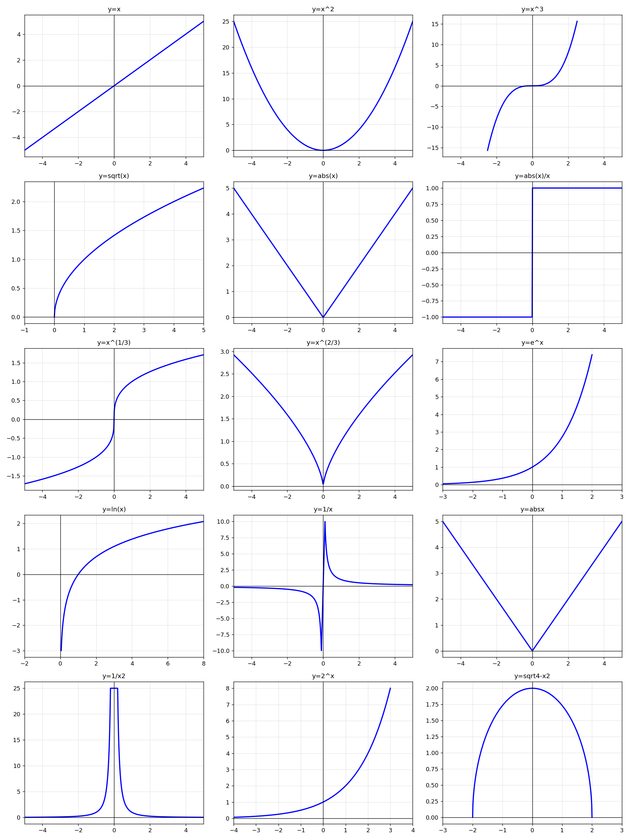
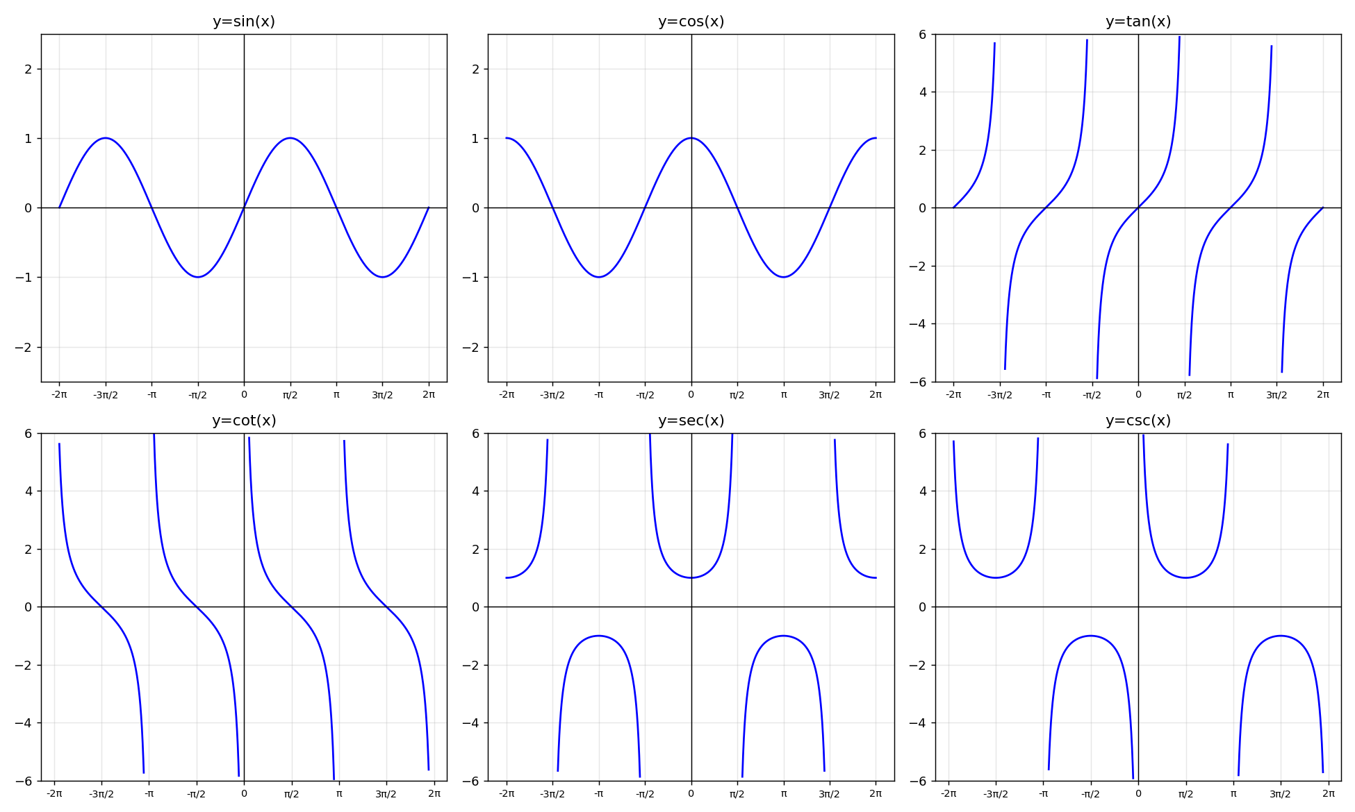
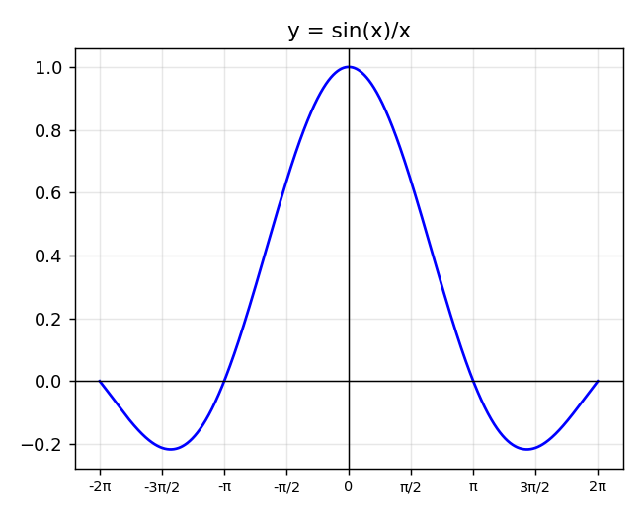
Key features to remember
y=x, y=x³, y=x^(1/3): odd functions, symmetric about the origin
y=x², y=x^(2/3), y=|x|: even functions, symmetric about the y-axis, V or U shaped
y=√x: domain/range [0,∞), starts at origin
y=|x|/x: equals 1 for x>0 and −1 for x<0 — a step function with a hole at x=0
y=eˣ and y=2ˣ: horizontal asymptote y=0, always positive, increasing
y=ln(x): vertical asymptote x=0, domain (0,∞)
y=1/x and y=1/x²: vertical asymptote x=0; y=1/x also has horizontal asymptote y=0 and odd symmetry; y=1/x² is even and always positive
y=sin x, y=cos x: period 2π, amplitude 1
y=tan x, y=cot x, y=sec x, y=csc x: vertical asymptotes wherever the reciprocal/related function is zero
y=√(4−x²): upper semicircle of radius 2 centered at the origin
y=sin(x)/x: removable discontinuity (hole) at x=0 where the value approaches 1; decaying oscillation elsewhere

Topic D: Function Transformations
If f(x) = x² − 1, describe each transformation:
1) f(x) − 4
Shifts the entire graph down 4 units
2) f(x − 4)
Shifts the entire graph right 4 units
3) −f(x + 2)
Shifts the graph left 2 units, then reflects it over the x-axis
4) 5f(x) + 3
Vertically stretches the graph by a factor of 5, then shifts it up 3 units
5) f(2x)
Horizontally compresses the graph toward the y-axis by a factor of 1/2
6) |f(x)|
Any portion of the graph below the x-axis is reflected upward (mirrored above the axis); portions already above the x-axis are unchanged
The given graph is a piecewise-linear path through the points (−5,0), (−3,0), (0,4), (2,−2), (3,0), (5,0). Each transformation below was built by applying the rule to those key points:
Sketches 7–12, based on the given graph of y = f(x)
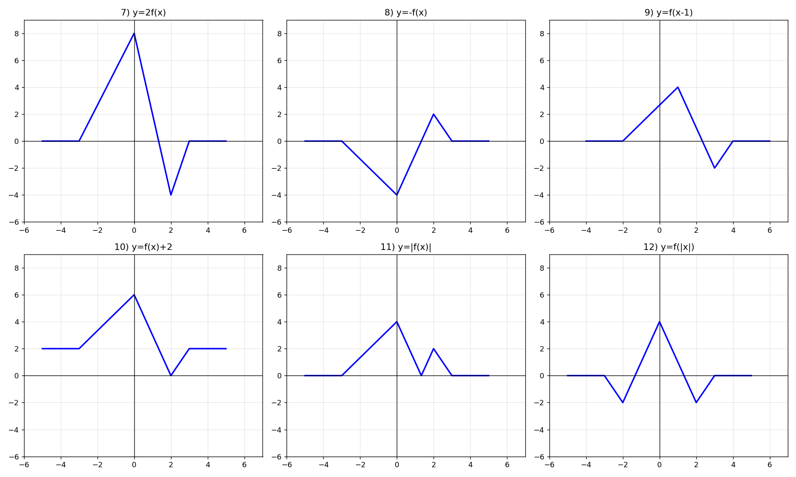

Topic E: Special Factorization
1) x³ + 8
Sum of cubes: (x+2)(x² − 2x + 4)
2) x³ − 8
Difference of cubes: (x−2)(x² + 2x + 4)
3) 27x³ − 125y³
Difference of cubes with (3x) and (5y): (3x − 5y)(9x² + 15xy + 25y²)
4) x⁴ + 11x² − 80
Treat as a quadratic in x²: (x²−5)(x²+16) — check: −5·16=−80, −5+16=11 ✓
5) ac + cd − ab − bd
Group: c(a+d) − b(a+d) = (a+d)(c−b)
6) 2x² + 50y² − 20xy
Factor out 2: 2(x² − 10xy + 25y²) = 2(x−5y)²
7) x² + 12x + 36 − 9y²
x²+12x+36 = (x+6)² → (x+6)² − (3y)² = (x+6−3y)(x+6+3y)
8) x³ − xy² + x²y − y³
Group: x(x²−y²) + y(x²−y²) = (x+y)(x²−y²) = (x+y)(x−y)(x+y) = (x−y)(x+y)²
9) (x−3)²(2x+1)³ + (x−3)³(2x+1)²
Factor out common (x−3)²(2x+1)²:
= (x−3)²(2x+1)² [ (2x+1) + (x−3) ]
= (x−3)²(2x+1)²(3x−2)

Topic F: Linear Functions
1a) m = −7 through (−3, −7)
y − (−7) = −7(x − (−3)) → y + 7 = −7(x + 3)
1b) m = −1/2 through (2, −8)
y + 8 = −(1/2)(x − 2)
2a) Through (−3, 6) and (−1, 2)
slope = (2−6)/(−1−(−3)) = −4/2 = −2
y − 6 = −2(x + 3)
2b) Through (−7, 1) and (3, −4)
slope = (−4−1)/(3−(−7)) = −5/10 = −1/2
y − 1 = −(1/2)(x + 7)
3a) Through (5,−3): parallel/perpendicular to x+y=4
x+y=4 → slope = −1
Parallel (slope −1): y + 3 = −1(x − 5) → y = −x + 2
Perpendicular (slope 1): y + 3 = 1(x − 5) → y = x − 8
3b) Through (−6,2): parallel/perpendicular to 5x+2y=7
5x+2y=7 → slope = −5/2
Parallel (slope −5/2): y − 2 = −(5/2)(x + 6)
Perpendicular (slope 2/5): y − 2 = (2/5)(x + 6)

Topic G: Solving Quadratic and Polynomial Equations
1) x² + 7x − 18 = 0
(x+9)(x−2)=0 → x = −9, 2
2) x² + x + 1/4 = 0
(x + 1/2)² = 0 → x = −1/2 (double root)
3) 2x² − 72 = 0
x² = 36 → x = ±6
4) 12x² − 5x = 2
12x² − 5x − 2 = 0 → (4x+1)(3x−2)=0 → x = −1/4, 2/3
5) 20x² − 56x + 15 = 0
(10x−3)(2x−5)=0 → x = 3/10, 5/2
6) 81x² + 72x + 16 = 0
(9x+4)² = 0 → x = −4/9 (double root)
7) x + 1/x = 17/4
Multiply by 4x: 4x² − 17x + 4 = 0 → (4x−1)(x−4)=0 → x = 1/4, 4
8) x³ − 5x² + 5x − 25 = 0
Factor by grouping: x²(x−5) + 5(x−5) = (x−5)(x²+5)
Over the reals, x²+5 has no real roots, so x = 5
9) 2x⁴ − 15x³ + 18x² = 0
Factor out x²: x²(2x²−15x+18)=0 → x²(2x−3)(x−6)=0
x = 0 (double), x = 3/2, x = 6

Topic H: Asymptotes
1) y = (x−1)/(x+5)
Already fully reduced. VA: x = −5. HA: degree of num = degree of den, ratio of leading coefficients → y = 1. No holes.
2) y = 8/x²
VA: x = 0. HA: y = 0 (degree of denominator is higher). No holes.
3) y = (2x+16)/(x+8)
= 2(x+8)/(x+8) = 2, with a hole where x+8=0
No VA. Hole at (−8, 2). The simplified function is just the horizontal line y = 2 with that point removed.
4) y = (2x²+6x)/(x²+5x+6)
Factor: 2x(x+3) / [(x+2)(x+3)] = 2x/(x+2), hole at x=−3
VA: x = −2. HA: y = 2 (ratio of leading coefficients). Hole: plug x=−3 into 2x/(x+2) → 2(−3)/(−1) = 6, so hole at (−3, 6).
5) y = x/(x²−25)
VA: x = 5 and x = −5. HA: y = 0 (denominator degree higher). No holes.
6) y = (x²−5)/(2x²−12)
VA: 2x²=12 → x = ±√6. HA: y = 1/2 (ratio of leading coefficients). No holes (numerator zero at x=±√5, different points).
7) y = x³/(x²+4)
x²+4 is never zero for real x, so there is no VA.
Degree of numerator exceeds denominator by 1 → slant asymptote instead of a HA.
Long division: x³ = x(x²+4) − 4x, so y = x − 4x/(x²+4). Slant asymptote: y = x.
8) y = (x³+4x)/(x³−2x²+4x−8)
Factor: x(x²+4) / [(x−2)(x²+4)] = x/(x−2)
Since x²+4 has no real root, cancelling it removes no real point — no hole.
VA: x = 2. HA: y = 1 (ratio of leading coefficients).
9) y = (10x+20)/(x³−2x²−4x+8)
Factor denominator: x³−2x²−4x+8 = (x−2)²(x+2)
y = 10(x+2) / [(x−2)²(x+2)] = 10/(x−2)², hole at x=−2
VA: x = 2. HA: y = 0. Hole: plug x=−2 into 10/(x−2)² → 10/16 = 5/8, so hole at (−2, 5/8).

Topic I: Negative and Fractional Exponents
1) −12²x⁻⁵
= −144/x⁵ (note: only x is raised to −5; the −12² is computed first as −144)
2) (−12x⁵)⁻²
= 1/(−12x⁵)² = 1/(144x¹⁰)
3) (4x⁻¹)⁻¹
= 4⁻¹x¹ = x/4
4) (−4/x⁴)⁻³
= (x⁴/−4)³ = x¹²/(−64) = −x¹²/64
5) (5x³/y²)⁻³
= (y²/(5x³))³ = y⁶/(125x⁹)
6) (x³−1)⁻²
= 1/(x³−1)²
7) (121x⁸)^(1/2)
= √121 · √(x⁸) = 11x⁴
8) (8x²)^(−4/3)
= 1/(8x²)^(4/3) = 1/(8^(4/3)·x^(8/3)) = 1/(16x^(8/3)) since 8^(4/3) = (∛8)⁴ = 2⁴ = 16
9) (−32x⁻⁵)^(−3/5)
= 1/(−32x⁻⁵)^(3/5) = x³/(−32)^(3/5)
(−32)^(1/5) = −2, so (−32)^(3/5) = (−2)³ = −8
Result: x³/(−8) = −x³/8

Topic J: Exponential Functions and Logarithms
1) log₂(1/4)
1/4 = 2⁻², so log₂(1/4) = −2
2) log₈(4)
8 = 2³, 4 = 2². log₈4 = log₂4/log₂8 = 2/3
3) ln(1/∛(e²))
= ln(e^(−2/3)) = −2/3
4) 5^(log₅40)
By the inverse property, this is simply 40
5) e^(ln 12)
By the inverse property, this is simply 12
6) log₁₂2 + log₁₂9 + log₁₂8
= log₁₂(2·9·8) = log₁₂(144) = log₁₂(12²) = 2
7) log₂(2/3) + log₂(3/32)
= log₂[(2/3)(3/32)] = log₂(2/32) = log₂(1/16) = −4
8) log_(1/3)(4/3) − log_(1/3)(12)
= log_(1/3)[(4/3)/12] = log_(1/3)(1/9) = 2 since (1/3)²=1/9
9) log₃((√3)⁵)
(√3)⁵ = 3^(5/2), so log₃(3^(5/2)) = 5/2
10) log₅(3x−8) = 2
3x−8 = 5² = 25 → 3x = 33 → x = 11
11) log₉(x²−x+3) = 1/2
x²−x+3 = 9^(1/2) = 3 → x²−x = 0 → x(x−1)=0 → x = 0 or 1 (both check in the domain)
12) log(x−3) + log5 = 2
log[5(x−3)] = 2 → 5(x−3) = 100 → x−3 = 20 → x = 23
13) log₂(x−1) + log₂(x+3) = 5
(x−1)(x+3) = 32 → x²+2x−35=0 → (x+7)(x−5)=0 → x=5 or x=−7
Domain requires x>1, so only x = 5 is valid
14) log₅(x+3) − log₅x = 2
log₅[(x+3)/x] = 2 → (x+3)/x = 25 → x+3 = 25x → x = 3/24 = 1/8
15) ln(x³) − ln(x²) = 1/2
This simplifies to ln(x) = 1/2 → x = e^(1/2) = √e
16) 3^(x−2) = 18
x−2 = log₃18 → x = 2 + log₃18 ≈ 4.631
17) e^(3x+1) = 10
3x+1 = ln10 → x = (ln10 − 1)/3 ≈ 0.434
18) 8ˣ = 5^(2x−1)
x·ln8 = (2x−1)ln5 → x·ln8 − 2x·ln5 = −ln5 → x(ln8 − 2ln5) = −ln5
x = ln5 / (2ln5 − ln8) ≈ 1.412

Topic K: Basic Right Angle Trigonometry
1) P(−2, 4)
r = √((−2)²+4²) = √20 = 2√5
sinθ = 4/(2√5) = 2√5/5 cosθ = −2/(2√5) = −√5/5 tanθ = 4/−2 = −2
cscθ = √5/2 secθ = −√5 cotθ = −1/2
2) P(√5, −2)
r = √(5+4) = 3
sinθ = −2/3 cosθ = √5/3 tanθ = −2/√5 = −2√5/5
cscθ = −3/2 secθ = 3/√5 = 3√5/5 cotθ = −√5/2
3) cosθ = −5/13, Quadrant II — find sinθ, tanθ
In QII, sine is positive: sinθ = √(1 − 25/169) = √(144/169) = 12/13
tanθ = sinθ/cosθ = (12/13)/(−5/13) = −12/5
4) cotθ = 2√10/3, Quadrant III — find sinθ, cosθ
Reference triangle: adjacent = 2√10, opposite = 3, hypotenuse = √(40+9) = 7
In QIII both sin and cos are negative: sinθ = −3/7, cosθ = −2√10/7
5) State the quadrant
a) sinθ>0 and cosθ<0 → Quadrant II
b) cscθ<0 and cotθ>0 → Quadrant III (sinθ<0 and cosθ<0)
c) tanθ>0 and secθ<0 → Quadrant III (cosθ<0, same sign as sinθ)
6) Special right triangles
30-60-90 triangle with shorter leg 1: hypotenuse = 2, longer leg = √3 (sides opposite 30°, 60°, 90° are 1, √3, 2)
45-45-90 triangle with legs 1: hypotenuse = √2

Topic L: Trigonometric Identities
1) (1+sinx)(1−sinx) = cos²x
Left side: (1+sinx)(1−sinx) = 1 − sin²x (difference of squares)
By the Pythagorean identity, 1 − sin²x = cos²x. ✓
2) sec²x + 3 = tan²x + 4
Pythagorean identity: sec²x = tan²x + 1
Left side becomes: (tan²x + 1) + 3 = tan²x + 4, which matches the right side. ✓
3) (1−secx)/(1−cosx) = −secx
Rewrite secx as 1/cosx: numerator = 1 − 1/cosx = (cosx−1)/cosx
So the fraction becomes [(cosx−1)/cosx] / (1−cosx) = (cosx−1) / [cosx(1−cosx)]
cosx−1 = −(1−cosx), so this is −(1−cosx) / [cosx(1−cosx)] = −1/cosx = −secx. ✓
4) 1/(1+tanx) + 1/(1+cotx) = 1
Write cotx = 1/tanx. Second term: 1/(1+1/tanx) = tanx/(tanx+1)
Sum: 1/(1+tanx) + tanx/(1+tanx) = (1+tanx)/(1+tanx) = 1. ✓

Topic M: Solving Trigonometric Equations on [0, 2π)
1) sin²x = sinx
sinx(sinx−1) = 0 → sinx = 0 or sinx = 1
x = 0, π (from sinx=0) and x = π/2 (from sinx=1)
Solutions: x = 0, π/2, π
2) 3tan³x = tanx
tanx(3tan²x − 1) = 0 → tanx = 0 or tan²x = 1/3
tanx=0: x = 0, π. tanx = 1/√3: x = π/6, 7π/6. tanx = −1/√3: x = 5π/6, 11π/6
Solutions: x = 0, π/6, 5π/6, π, 7π/6, 11π/6
3) sin²x = 3cos²x
Divide by cos²x: tan²x = 3 → tanx = ±√3
Solutions: x = π/3, 2π/3, 4π/3, 5π/3
4) cosx + sinx·tanx = 2
Rewrite tanx=sinx/cosx: cosx + sin²x/cosx = (cos²x+sin²x)/cosx = 1/cosx
So 1/cosx = 2 → cosx = 1/2
Solutions: x = π/3, 5π/3
5) sinx = cosx
Divide both sides by cosx: tanx = 1
Solutions: x = π/4, 5π/4
6) 2cos²x + sinx − 1 = 0
Use cos²x = 1−sin²x: 2(1−sin²x)+sinx−1 = 0 → −2sin²x+sinx+1=0 → 2sin²x−sinx−1=0
(2sinx+1)(sinx−1)=0 → sinx = −1/2 or sinx = 1
Solutions: x = π/2, 7π/6, 11π/6

Topic N: Using the Graphing Calculator (numeric solutions)
1) 3x³ − x − 5 = 0
One real zero (the other two roots are complex): x ≈ 1.279
2) 2x² − 1 = 2ˣ
Two intersection points: x ≈ −0.879 and x ≈ 1.323
3) 2ln(x+1) = 5cosx on [0, 2π)
Two solutions in the interval: x ≈ 1.242 and x ≈ 5.564
4) f(x)=x⁴−6.5x²+6x+2 and g(x)=1+x+e^(x²−2x)
Four intersection points:
x ≈ 0, y = 2
x ≈ 1.033, y ≈ 2.401
x = 2, y = 4
x ≈ 3.262, y ≈ 65.640
5) h(x) = 2x⁵ − 3x⁴ + x − 4
h′(x) = 10x⁴ − 12x³ + 1 = 0 gives critical points x ≈ 0.531 and x ≈ 1.131
Second-derivative test (h″(x)=40x³−36x²): at x≈0.531, h″<0 → relative maximum at (0.531, −3.623)
At x≈1.131, h″>0 → relative minimum at (1.131, −4.077)

